Ideation Phase
Brainstorm & Idea Prioritization Template

Date | 20 february 2026
Team ID | LTVIP2026TMIDS72915
Project Name | Project name: - Measuring the pulse of prosperity: - An index of economic freedom analysis
Maximum Marks | 4 Marks

Brainstorm & Idea Prioritization Template:
Brainstorming provides a free and open environment that encourages everyone within a team to participate in the creative thinking process that leads to problem solving. Prioritizing volume over value, out-of-the-box ideas are welcome and built upon, and all participants are encouraged to collaborate, helping each other develop a rich number of creative solutions.

Step-1: Team Gathering, Collaboration and Select the Problem Statement.

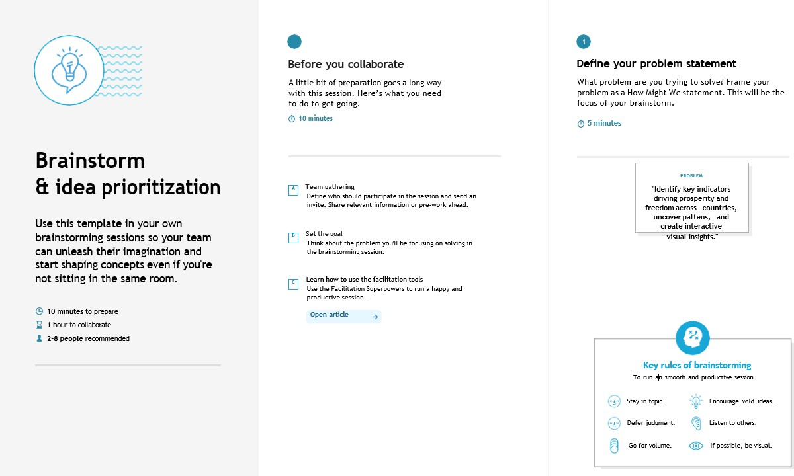

Step-2: Brainstorm, Idea Listing and Grouping
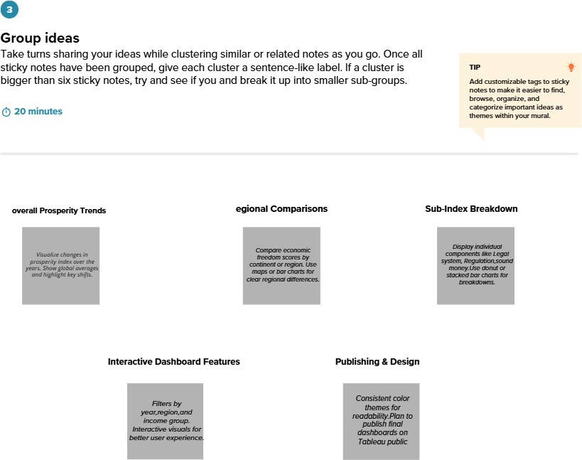
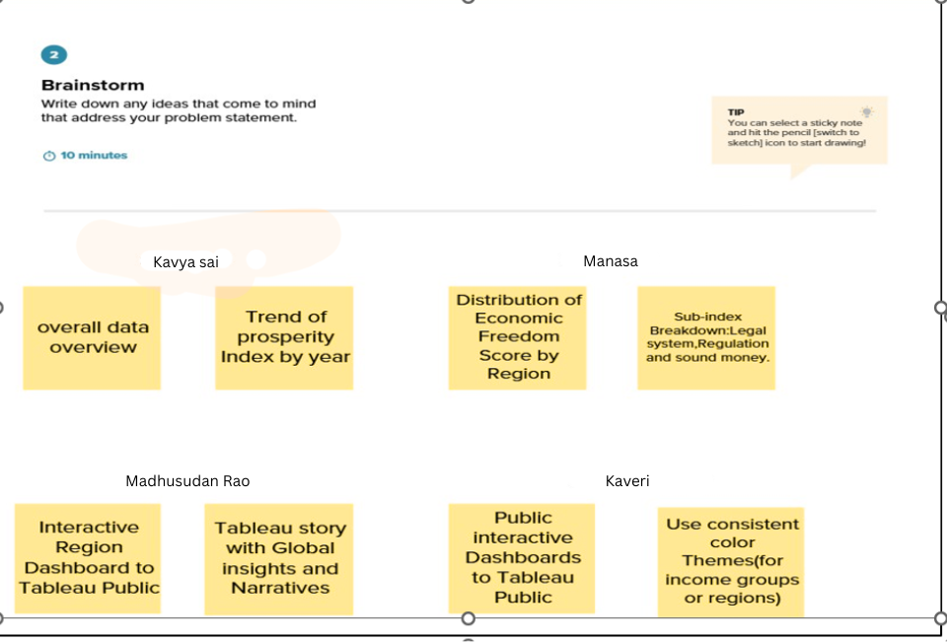

Step-3: Idea Prioritization
